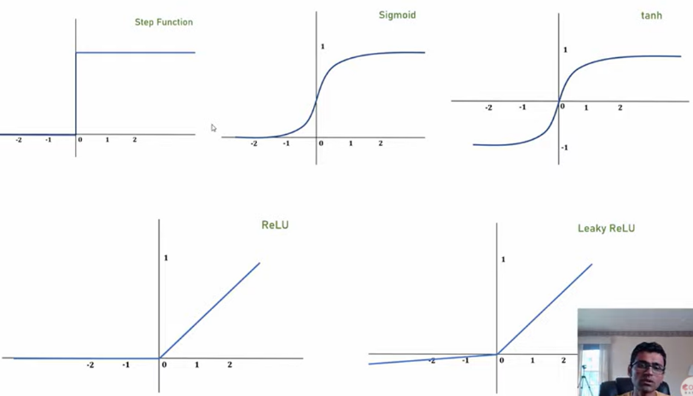

Use ReLu o LReLu en hidden layers

No use tanh

Para salida

* Para clasification Softmax
* Para linear Regression
* Para binario sigmoid

Sigmoid

|  |  |
| --- | --- |
|  |  |

For sigmoid function, we have 0, and then in the middle a range, until it is 1.

So fro the clasification: if it has an insurance, before 30 years old it is not, then from 30-45 most likely, if it it above 0.5, then if it is more than 45 years old it is sure it has insurance. In this case the difficulty of prediction is between 30-45.

For having insurance is between TRUE – FALSE.

For number classification, in this case it is ‘4’ and with sigmoid is a range, we get the highest one, 0.82, in this case there may be others higher than 0.5, but we will take the highest.

**STEP Funtion,**

it is 0 or 1, no middle values. This is for the last layer, binary, true, false, we don’t want to decide if it is close to 1.

En el caso de los seguros, menos de 48 anios, no tiene, no se tiene un porcentaje, o tiene o no tiene.

Y en el caso de reconocer imágenes, podría darse que existen 2 posibles resultados favorables.

|  |  |
| --- | --- |
|  |  |

Hasta este momento nos dice que

* Para clasificación binaria, usar step, o es true o es false.
* Para clasificación varios, usar sigmoid, y tomar el de mayor resultado

**Tanh**

**Va de -1, 1**

|  |  |
| --- | --- |
|  |  |

Use sigmoid for outer layer

Use ReLu / tanh in the middle layers